Nonlinear_Diff_Equa_Dyna_Sys_2E_Ferdinand_Verhulst_C01

1 Introduction

p11

1.1 Definitions and notation
1.1 Definiciones y notación

This section contains material which is basic to the development of the theory in the subsequent chapters. We shall consider differential equations of the form
—-------------------------------------
Esta sección contiene material que es básico para el desarrollo de la teoría en los capítulos siguientes. Consideraremos ecuaciones diferenciales de la forma

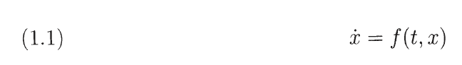
—-------------------------------------

\[
\dot{x} = f(t,x)
\]

using Newton's fiuxie notation $\dot{x} = dxldt$. The variable t is a scalar, $t \in \mathbb{R}$t, often identified with time. The vector function $f: G \rightarrow \mathbb{R}^n$ is continuous in t and x; G is an open subset of $\mathbb{R}^{n+1}$, so $ x\in \mathbb{R}^n$.
—-------------------------------------

usando la notación fiuxie de Newton $\dot{x} = dxldt$. La variable t es un escalar, $t \in \mathbb{R}$t, a menudo identificada con el tiempo. La función vectorial $f: G \rightarrow \mathbb{R}^n$ es continua en t y x; G es un subconjunto abierto de $\mathbb{R}^{n+1}$, entonces $ x\in \mathbb{R}^n$.
—-------------------------------------

The vector function x(t) is a solution of equation 1.1. on an interval $I \subset \mathbb{R}$ if
$x: I \rightarrow \mathbb{R}^n$ is continuously differentiable and if x(t) satisfies equation (1.1).
—-------------------------------------
La función vectorial x(t) es una solución de la ecuación 1.1. en un intervalo $I \subset \mathbb{R}$ si $x: I \rightarrow \mathbb{R}^n$ es continuamente diferenciable y si x(t) satisface la ecuación (1.1).
—-------------------------------------

All variables will be real and the vector functions will be real-valued unless explicitly stated otherwise. Apart from equations of the form (1.1) we shall also consider scalar equations like
—-------------------------------------
Todas las variables serán reales y las funciones vectoriales tendrán valores reales a menos que se indique explícitamente lo contrario. Además de las ecuaciones de la forma (1.1), también consideraremos ecuaciones escalares como

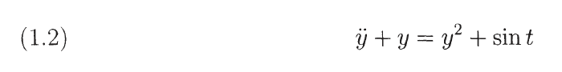
—-------------------------------------

\[
\ddtot{y} + y = y^2 + sin t
\]

in which $\ddot{y} = d^2y I dt^2$.

Equation (1.2) can be put into the form of equation (1.1) by introducing $y = y_1, \dot{y} = y_2$ which yields the system
—-------------------------------------
La ecuación (1.2) se puede poner en la forma de la ecuación (1.1) introduciendo $y = y_1, \dot{y} = y_2$ que produce el sistema
—-------------------------------------

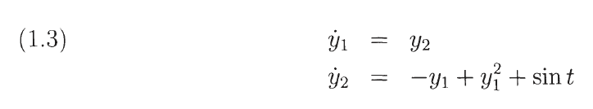

begin{array}{rc}
\dot{y}_1 & = & y_2 \\
\dot{y} & = & -y_1 + y^2_1 + \sin t
\end{array}

Equation (1.3) is clearly in the form of equation (1.1); the vector x in (1.1) has in the case of (1.3) the components $y_1$ and $y_2$, the vector function f has the components $y_2$ and $-y_1 + y^2_1 + \sin t$. It is easy to see that the general nth order scalar equation
—-------------------------------------
La ecuación (1.3) tiene claramente la forma de la ecuación (1.1); el vector x en (1.1) tiene en el caso de (1.3) las componentes $y_1$ y $y_2$, la función vectorial f tiene las componentes $y_2$ y $-y_1 + y^2_1 + \sin t$. Es fácil ver que la ecuación escalar general de n-ésimo orden

—-------------------------------------

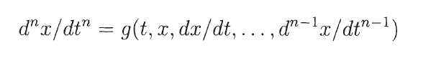

\[
d^n x / dt^n = g(t, x, dx/dt, …, d^{n-1} x / dt^{n-1}
\}

with $g: \mathbb{R}^{n+1} \rightarrow \mathbb{R}$, can also be put into the form of equation (1.1).

Depending on the formulation of the problem, it will be useful to have at our disposal both scalar equations and their vector form.
—-------------------------------------------
Dependiendo de la formulación del problema, será útil tener a nuestra disposición tanto ecuaciones escalares como su forma vectorial.
—--------------------------------------------

In some parts of the theory we shall make use of the Taylor expansion of a vector function f(t, x). The notation $\partialf / \partial x$ indicates the derivative with respect to the (spatial) variable x; this means that $\partialf / \partial x$ is the $n \times n$ matrix
—--------------------------------------------

En algunas partes de la teoría haremos uso de la expansión de Taylor de una función vectorial f(t, x). La notación $\parcialf / \parcial x$ indica la derivada con respecto a la variable (espacial) x; esto significa que $\partialf / \partial x$ es la matriz $n \times n$
—--------------------------------------------

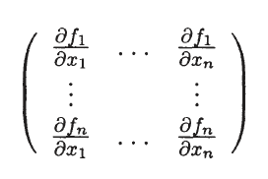

\begin{pmatrix}
\frac{\partial f_1}{\partial x_1} & ... & \frac{\partial f_1}{\partial x_n}\\
\vdots & \ddots & \vdots \\
\frac{\partial f_n}{\partial x_1} & ... & \frac{\partial f_n}{\partial x_n}
\end{pmatrix}

with $x_1l, ... ,x_n$ the components of x and $f_1, … , f_n$ the components of f(t, x).

If we do not state an explicit assumption about the differentiability of the vector function f(t, x), we assume it to have a convergent Taylor expansion in the domain considered. More often than not, this assumption can be weakened if necessary. In a number of cases we shall say that the vector function is smooth, which means that the function has continuous first derivatives.
—--------------------------------------------
Si no enunciamos un supuesto explícito sobre la diferenciabilidad de la función vectorial f(t, x), asumimos que tiene una expansión de Taylor convergente en el dominio considerado. La mayoría de las veces, esta suposición puede debilitarse si es necesario. En varios casos diremos que la función vectorial es suave, lo que significa que la función tiene primeras derivadas continuas.

—--------------------------------------------

In studying vector functions in $\mathbb{R^n}$ we shall employ the norm

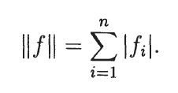

\[
||f|| = \sum_{i=1}^n |f_i|
\]

For the $n \times n$ matrix A with elements $a_{ij}$ we shall use the norm

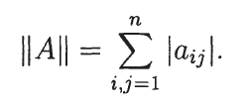

\[
||A|| = \sum_{i,j=1}^n |a_{i,j}|
\]

Of course these are norms only if I is a constant vector and A is a constant matrix. With some abuse of language we shall still call $II \dot II$ a norm if I is a vector function and A a matrix function. A proper norm will be defined below.
—-----------------------------------
Por supuesto, estas son normas solo si I es un vector constante y A es una matriz constante. Abusando un poco del lenguaje, seguiremos llamando a $II \dot II$ una norma si I es una función vectorial y A una función matricial. A continuación se definirá una norma adecuada.
—-----------------------------------

In the theory of differential equations the vector functions depend on variables like t and x. We shall use some straightforward generalisations of concepts in basic analysis. For instance the expression
—-----------------------------------

En la teoría de ecuaciones diferenciales las funciones vectoriales dependen de variables como t y x. Usaremos algunas generalizaciones directas de conceptos en el análisis básico. Por ejemplo la expresión
—-----------------------------------
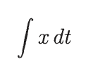

\[
\int x dt
\]

is short for the vector field with components
—----------------------------------
es la abreviatura de campo vectorial con componentes
—----------------------------------
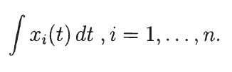

\[
\int x_i(t) dt, i=1,...,n
\]

In the same way $\int A(t) dt$ represents a $n \times n$ matrix with elements $\int a_{ij}(t) dt, i,j=1,...,n$.

Finally, in estimating the magnitude of vector functions, we shall use the uniform norm or supnorm. Suppose that we are considering the vector function I(t,x) for $t_0 \leq t \leq t_0+T$ and $x \in D$ with D a bounded domain in $\mathbb{R}$; then
—----------------------------------
Finalmente, al estimar la magnitud de las funciones vectoriales, usaremos la norma uniforme o supnorma. Supongamos que estamos considerando la función vectorial I(t,x) para $t_0 \leq t \leq t_0+T$ y $x \in D$ con D un dominio acotado en $\mathbb{R}$; después

—----------------------------------
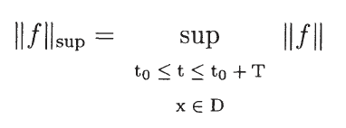

\[
||f||_{sup} = sup_{\begin{matrix}
t_0 \leq t \leq t_0+T\\
x \in D

\end{matrix}} ||f||
\]

1.2 Existence and uniqueness
Existencia y unicidad.

The vector function f(t, x) in the differential equation (1.1) has to satisfy certain conditions, of which the Lipschitz condition is the most important one.
—---------------------------------------------
La función vectorial f(t, x) en la ecuación diferencial (1.1) tiene que satisfacer ciertas condiciones, de las cuales la condición de Lipschitz es la más importante.
—---------------------------------------------

\hfill

\textbf{Definition}

Consider the function f(t, x) with $f : \mathbb{R}^{n+1} \rightarrow \mathbb{R}^{n}, |t-t_0| \leq a, a\in D \subset \mathbb{R}^{n}$; f(t, x) satisfies the Lipschitz condition with respect to x if in $|t_0-a, t_0+a| \timeso D$ we have
—---------------------------------------------

Considere la función f(t, x) con $f : \mathbb{R}^{n+1} \rightarrow \mathbb{R}^{n}, |t-t_0| \leq a, a\in D \subset \mathbb{R}^{n}$; f(t, x) satisface la condición de Lipschitz con respecto a x si en $|t_0-a, t_0+a| \timeso D$ tenemos
—---------------------------------------------

\[
||f(t, x_1) - f(t,x_2)|| \leq L ||x_1 - x_2||
\]

with $x_1, x_2 \in D$ and L a constant. L is called the Lipschitz constant.

Instead of saying that f(t,x) satisfies the Lipschitz condition one often uses the expression: f(t, x) is Lipschitz continuous in x. Note that Lipschitz continuity in x implies continuity in x.
—---------------------------------------------
En lugar de decir que f(t,x) satisface la condición de Lipschitz, a menudo se usa la expresión: f(t,x) es una continua de Lipschitz en x. Tenga en cuenta que la continuidad de Lipschitz en x implica continuidad en x.

—---------------------------------------------

It is easy to see that continuous differentiability implies Lipschitz continuity; this provides us in many applications with a simple criterion to establish whether a vector function satisfies this condition.
—---------------------------------------------
Es fácil ver que la diferenciabilidad continua implica la continuidad de Lipschitz; esto nos proporciona en muchas aplicaciones un criterio simple para establecer si una función vectorial satisface esta condición.

—---------------------------------------------

The Lipschitz condition plays an essential part in the following theorem.

\hfill

\textbf{Theorem 1.1}

Consider the initial value problem

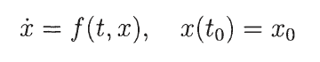

\[
\dot{x} = f(t, x), x(t_0) = X_0
\]

with $x \in D \subset \mathbb{R}^n, |t-t_0| \leq a; D = \{ x | ||x-x_0|| \leq d \}$, a and d are positive constants. The vector function f (t, x) satisfies the following conditions:

\begin{enumerate}[a.]
\item f(t, x) is continuous in $G = [t_0 - a, t_0 + a] \times D$;
\item f (t, x) is Lipschitz continuous in x
\end{enumerate}
.
Then the initial value problem has one and only one solution for $|t - t_0| \leq min(a, \frac{d}{M})$ with
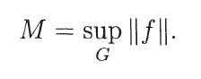

\[
M = sup_G llfll.
\]

The solution of the initial value problem will be indicated in the sequel by x(t), sometimes by x(t; xo) or x(t; to, xo). Note that theorem 1.1 guarantees the existence of the solution in a neighbourhood of $t = t_0$, the size of which depends on the supnorm M of the vector function f(t,x). Often one can continue the solution outside this neighbourhood; in many problems we shall not give a and d apriori but instead, while analysing the problem, we shall determine the time interval of existence and the domain D.
—----------------------------------------------
La solución del problema de valor inicial se indicará en la continuación por x(t), a veces por x(t; xo) o x(t; to, xo). Nótese que el teorema 1.1 garantiza la existencia de la solución en una vecindad de $t = t_0$, cuyo tamaño depende de la supnorma M de la función vectorial f(t,x). A menudo, uno puede continuar la solución fuera de este vecindario; en muchos problemas no daremos a y d a priori sino que, analizando el problema, determinaremos el intervalo de tiempo de existencia y el dominio D.
—----------------------------------------------

\hfill

\textbf{Example 1.1}

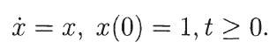

\[
\dot{x} = x, x(0) = 1, t \geq 0.
\]

The solution exists for $0 \leq t \leq a$ with a an arbitrary positive constant. The solution, $x(t) = e^t$ , can be continued for all positive t and it becomes unbounded for $t \rightarrow \infty $.
—--------------------------------------------
La solución existe para $0 \leq t \leq a$ con una constante positiva arbitraria. La solución, $x(t) = e^t$ , puede continuar para todo t positivo y se vuelve ilimitada para $t \rightarrow \infty $.
—--------------------------------------------

\hfill

\textbf{Example 1.2}

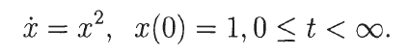

\[
\dot{x} = x^2 , x(0) = 1, 0 \leq t < \infty
\]

We find $x(t) = (1 - t)^{-1}$ so the solution exists for $0 \leq t < 1$. In this case we know
the solution explicitly; in estimating the time interval of existence we could take
$a = \infty$, d some positive constant. Then $M = (1 + d)^2$ and theorem 1.1 guarantees
existence and uniqueness for $0 \leq t \leq inf(\infty, d(d+1)^{-2}) = d(d+1)^{-2}$0. If, for
example, we are interested in values of x with upperbound 3, then $d = |3 - x_0 | = 2$.
—----------------------------------------------
Encontramos $x(t) = (1 - t)^{-1}$ por lo que la solución existe para $0 \leq t < 1$. En este caso conocemos la solución explícitamente; al estimar el intervalo de tiempo de existencia podríamos tomar $a = \infty$, d alguna constante positiva. Entonces $M = (1 + d)^2$ y el teorema 1.1 garantiza la existencia y unicidad de $0 \leq t \leq inf(\infty, d(d+1)^{-2}) = d(d+1) ^{-2}$0. Si, por ejemplo, estamos interesados en valores de x con límite superior 3, entonces $d = |3 - x_0 | = 2$.
—----------------------------------------------

Theorem 1.1 guarantees the existence of the solution for $0 \leq t \leq 2/9$. The actual
solution reaches the value 3 for t = 2/3.
—----------------------------------------------
El teorema 1.1 garantiza la existencia de la solución para $0 \leq t \leq 2/9$. La solución real alcanza el valor 3 para t = 2/3.

—----------------------------------------------

\hfill

1.3 Gronwall's inequality
In parts of the theory we shall use an inequality introduced by Gronwall in 1918.
The applications to the theory of differential equations are of later date and we
should mention the name of Richard Bellman in this respect. Keeping an eye on
our future use of the inequality we shall present here two versions of Gronwall's
inequality; there are more versions and extensions.

Theorem 1.2 (Gronwall).
Assume that for to :::; t :::; to + a, with a a positive constant, we have the estimate
(1.4) ¢(t) :::; 81 r '!f;(s)¢(s)ds + 83
lto
in which, for to :::; t :::; to + a, ¢(t) and '!f;(t) are continuous functions, ¢(t) :2: 0 and
'!f;(t) :2: 0; 81 and 83 are positive constants. Then we have for to :::; t :::; to + a
¢(t) :::; 83eD1I,: "'(s)ds
Proof
From the estimate 1.4 we derive
¢(t) < 1.
81 Itto '!f;(s)¢(s)ds + 83 -
Multiplication with 81'!f;(t) and integration yields
so that
which produces i t 6, J.' "'(s)ds 81 '!f;(s)¢(s)ds+83 :::;83e '0 •
to
Applying the estimate 1.4 again, but now to the lefthand side, yields the required
inequality. 0
It is an interesting exercise to demonstrate that if 83 = 0, the estimate 1.4 implies
that ¢( t) = 0, to :::; t :::; to + a.
Sometimes a modified version is convenient.
Theorem 1.3
Assume that for to :::; t :::; to + a, with a a positive constant, we have the estimate
(1.5)
in which for to :::; t :::; to + a ¢(t) is a continuous function, ¢(t) :2: 0; 81,82 ,83 are
constants with 81 > 0, 82 :2: 0, 83 :2: O. Then we have for to :::; t :::; to + a
¢(t) :::; (82 + 83) i,(t-to) _ 82 .
81 81
Proof
Put ¢(t) = '!f;(t) - ~, then the estimate (1.5) becomes
it 82
'!f;(t) :::; 81 '!f;(s)ds + T + 83 .

Application of theorem 1.2 yields
Replacing 1jJ(t) by ¢(t) + 152 /151 produces the required result. In the special case
that 152 = 153 = 0 we have ¢( t) = 0 for to :s t :s to + a (this case is left to the
reader). 0
We apply Gronwall's inequality to study the dependence of a solution on its initial
condition.
Theorem 1.4 (dependence on initial conditions).
Consider the equation x = f(t,x), x E IRn , f : IRn+1 ---> IRn , t ~ 0; f(t,x)
satisfies the Lipschitz condition (Lipschitz constant L) and is continuous in t and
x. Consider the initial value problems
x = f(t,x) ,x(O) = a, solution xo(t) on interval I;
x = f(t,x) ,x(O) = a+7], solution xe(t) on interval I.
If Ihll :s c (c real, positive) we have
Ilxo(t) - xc(t)11 :s ceLt on interval I.
Proof
The two initial value problems are equivalent to the integral equations:
Subtraction and applying the triangle inequality produces
and, using the Lipschitz condition,
Applying Gronwall's inequality (theorem 1.2) with 151 = L, 1jJ(s)
Ilxo(t) - xc(t)ll, 153 = c yields the result.
1, ¢(t) =
o

